

Wallet on Testnet – Set Up and Transact
School:.............................................................................................................Campus:....................................................... AcademicYear:......................SubjectName:...........................................................SubjectCode:..........................
Semester:...............Program:........................................Branch:.........................Specialization:.......................... Date: .....................................
(LearningbyDoingandDiscovery)
* Coding Phase: Pseudo Code / Flow Chart / Algorithm

 | Algorithm Steps:
 | 1. | • Download and set up a cryptocurrency wallet (such as MetaMask).  • Link your wallet to a test blockchain network.  • Obtain sample (test) tokens through a testnet faucet.  • Transfer some of those test tokens to a different wallet address.  • Check and confirm the transaction details on a testnet block explorer.
 | 2.
 | 3.
 | 4.
 | 5.

* Softwares used

- Web Browser (Chrome)
- MetaMask Wallet Extension
- Blockchain Testnet Explorer (e.g., Sepolia )
- Text Editor (VS Code)


Applied and Action Learning
tn

Applied and Action Learning

nnNd s
- Implementation Phase: Final Output (no error
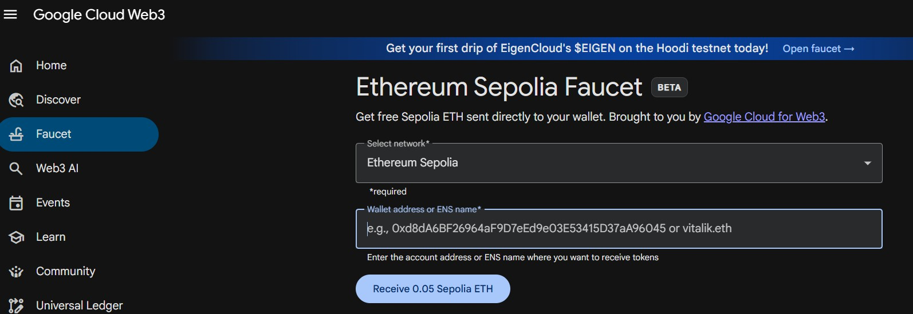
Go to the metamask wallet choose the testnet and select sepolia testnet.

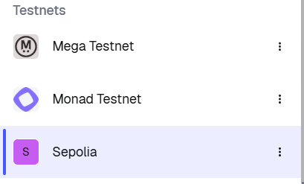
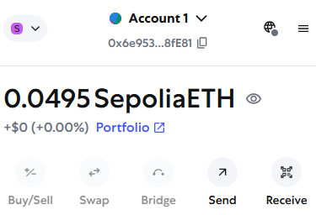

  - Then go to the sepolia faucet cloud to fauset some sepolia testnet
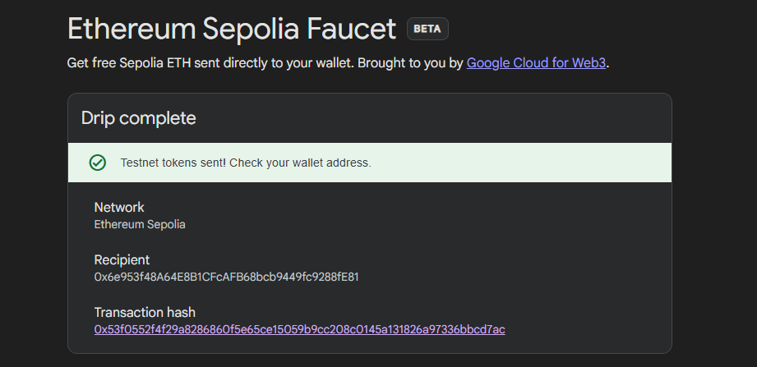
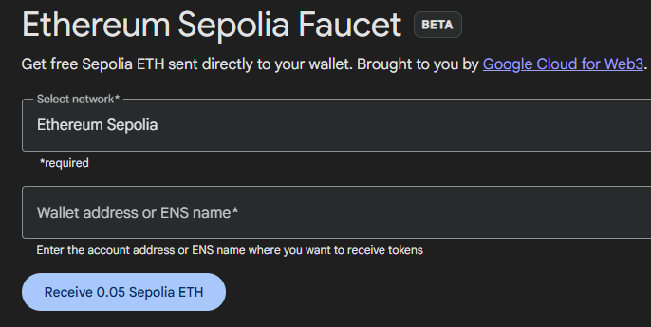



* Observations
It was found that Proof of Work (PoW) offers strong security due to its high computational effort, but it requires significant energy and time.
On the other hand, Proof of Stake (PoS) is more eco-friendly and faster, while still providing reliable security.

Rubrics
Concept | 10
Planning and Execution/  Practical Simulation/ Programming | 10
Result and Interpretation | 10
Record of Applied and Action Learning | 10
Viva | 10
Total | 50


Signature of the Student:
Signature of the Faculty:

